TABEL 1.5 ROBBY

No. 1

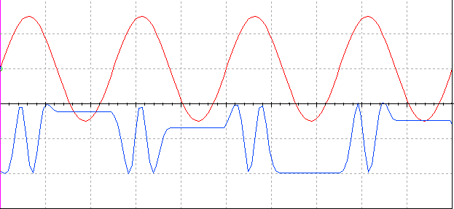

Fmax = 1/124.496 micro second  
Fmin = 1/(366.873 \*2) micro second

No. 2

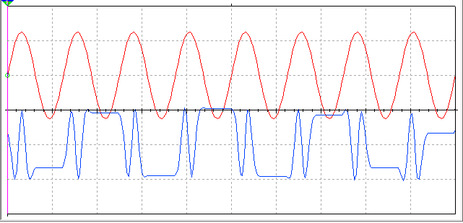

Fmax = 1/67.268 micro second  
Fmin = 1/(186.830\*2) micro second

No. 3

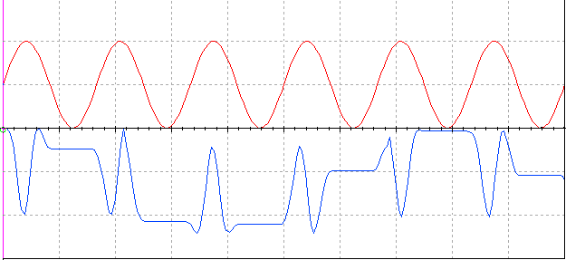

Fmax = 1/51.659 micro second  
Fmin = 1/(136.936\*2) micro second